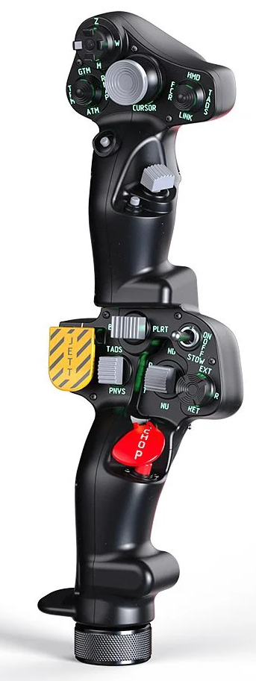  1xx - Controls | 2xx - Ground | 3xx - Flight | 4xx - A2A | 5xx - A2G | 6xx - Misc
102 - Controls - Pilot - Collective Grip Apache-64
U=Up, D=Down, F=Forward, B=Backward, L=Left, R=Right, P=Press, S-*=Shift-*, L-*=Long-*

Top Trigger
- P: --
FCR Scan Size hat (top) -- Radio select switch??
- U: Radio 1
- D: Radio 3
- R: Radio 2
- L: Radio 4
- P: Radio 5
FCR Mode hat (left) -- SCAS heading hold switch
- U: SCAS heading hold ENGAGE
- D: SCAS heading hold DISENGAGE
- R: SCAS heading hold RIGHT
- L: SCAS heading hold LEFT
- P: --
Sight Select hat (right) -- CHAN select switch
- U: Channel UP
- D: Channel DOWN
- L: KYBD
- R: FREQ
- P: --
Cursor hat (Ministick)
- Axes: --
- P: --
Cursor Select button (under ministick)
- P: --
FCR Scan switch (thumb) -- Comms
- F: (SRS radio 1 PTT)
- B: (SRS radio 2 PTT)
- P: (VoiceAttack PTT)
- S-P: (VoiceAttack center mouse cursor)
Cued Search button (under thumb switch)
- P: --
Top Pinky button
- P: --
-------------------------------------------------------------------------------------------------------------------------------------
Bottom trigger
- P: --
Boresight rocker
- L: --
- P: --
- R: --
Searchlight switch
- F: Searchlight switch ON??
- B: Searchlight switch OFF??
- B and Hold: Searchlight switch STOW??
Searchlight hat
- U/D/L/R: Searchlight up/down/left/right
- P: --
Jettison button
- P: Emergency Jettison Guard OPEN
- P and Hold: Emergency Jettison Switch Depress
NVS switch
- F: --
- P: --
- B: --
Stabilator switch -- RPM trim switch
- F: RPM increase
- P: RPM decrease
- B: --
Chop button
- P: --
- P and Hold: --
Bottom Pinky button
- P: --

